Emergency Response
Planning Template for Public
Drinking Water Systems
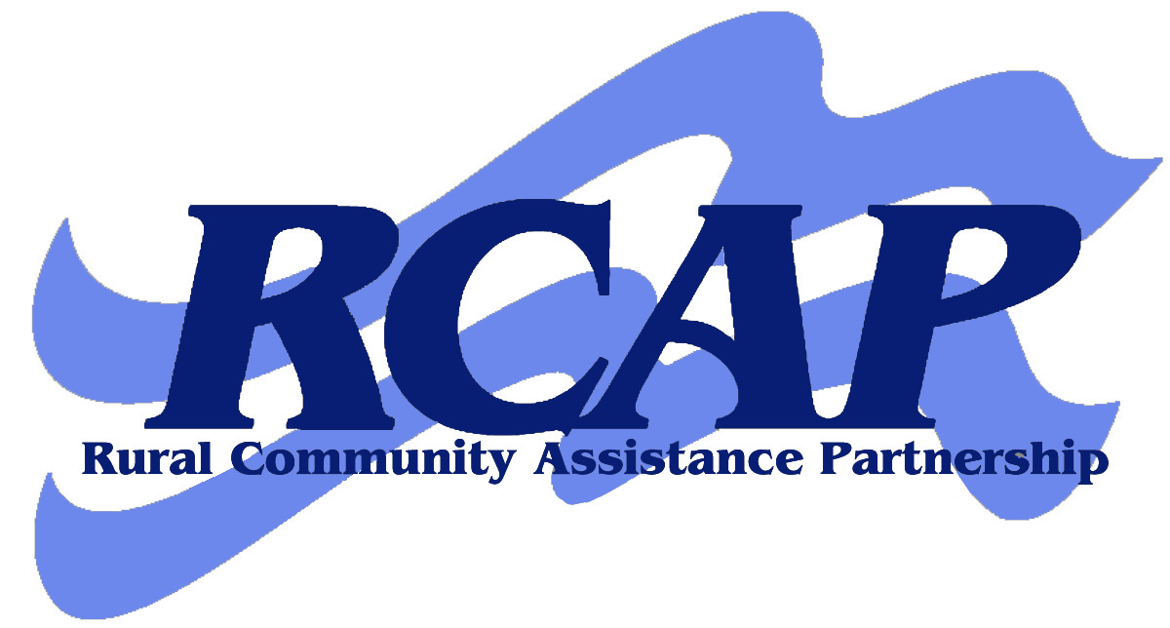


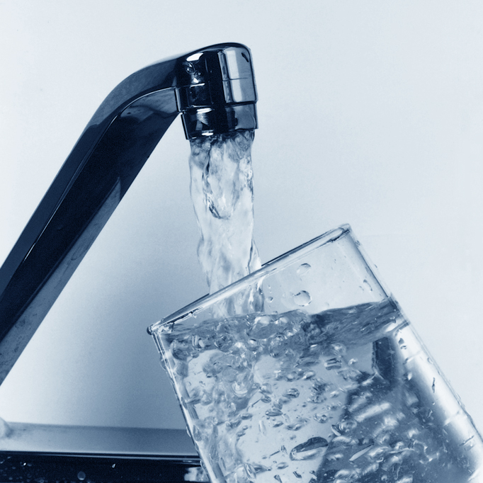

Rural Community Assistance Corporation
www.rcac.org

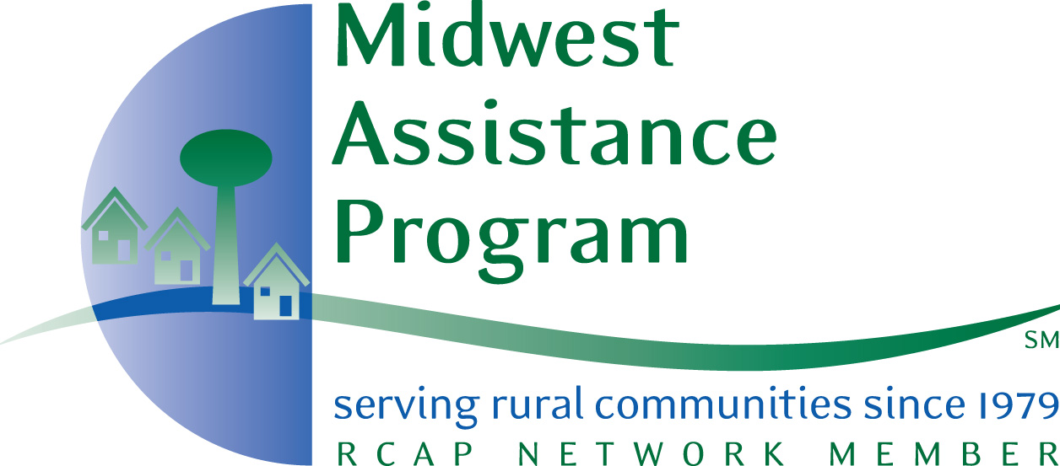


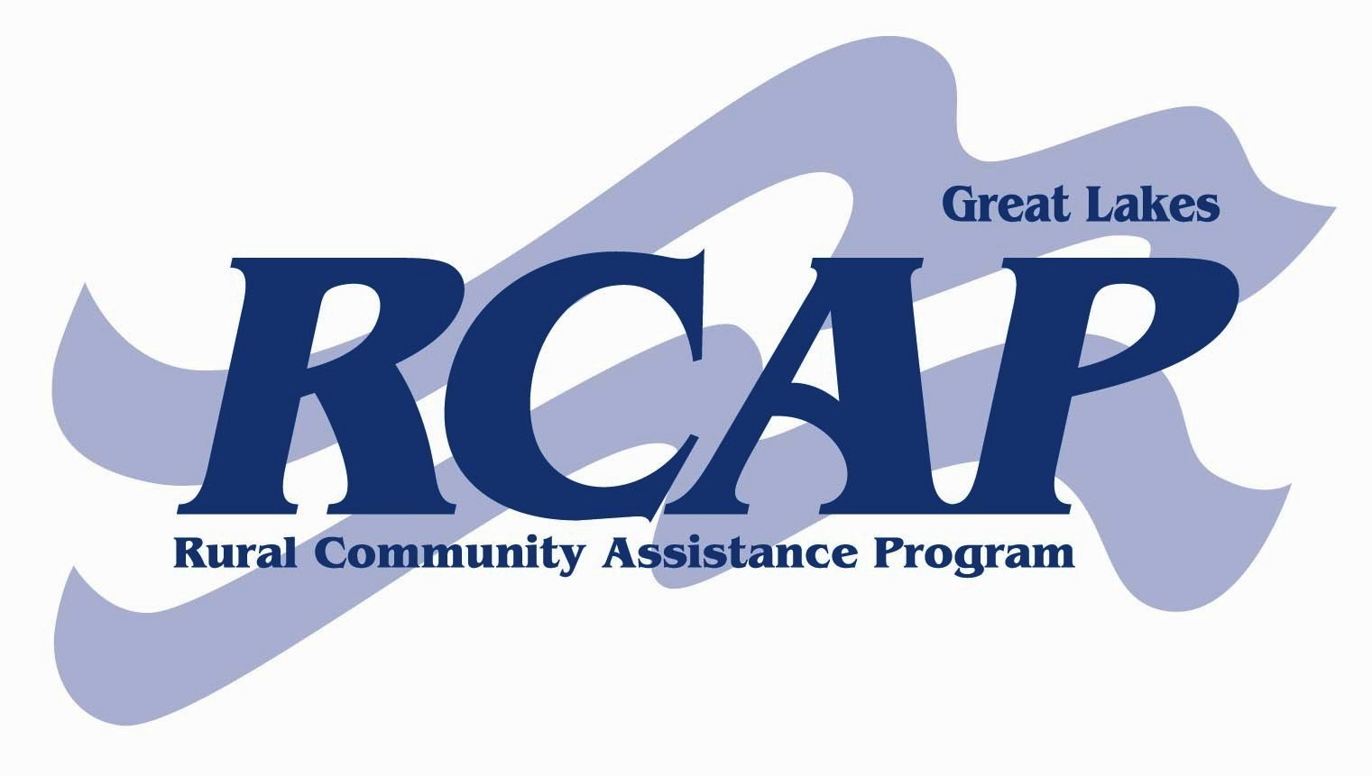



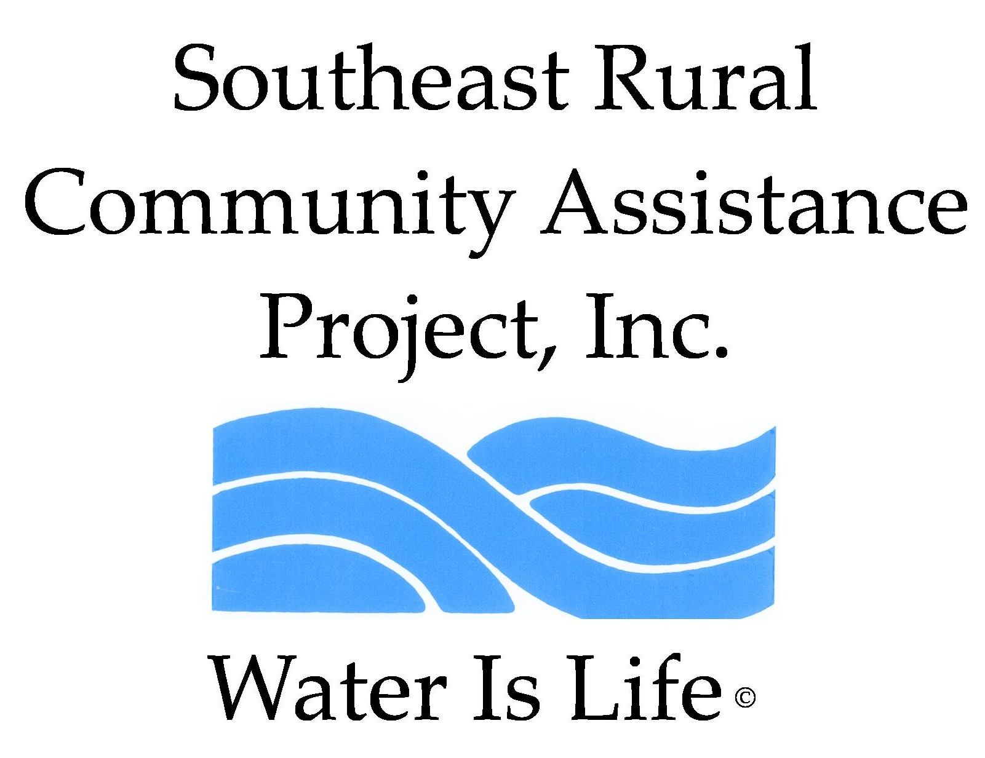

Produced for the Rural Community Assistance Partnership (RCAP) National Network
by Rural Community Assistance Corporation, Western RCAP
RCAP Safety and Security Education Program

Emergency Response
Planning Template for Public
Drinking Water Systems

RCAP Regional Offices:
If you need technical assistance to complete your Emergency Response Plan, please contact one of our regional offices listed below.

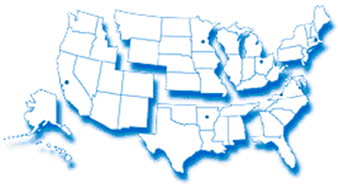
Western RCAP
Midwest RCAP
Great Lakes RCAP
Southern RCAP
RCAP National Office

Southeast RCAP

Northeast RCAP
Regional Offices | Contact Number | Web Address
RCAP National Office | 888/321-7227 | www.rcap.org
Western RCAP | 916/447-2854 | www.rcac.org
Southeast RCAP | 866/928-3731 | www.southeastrcap.org
Great Lakes RCAP | 800/775-9767 | www.glrcap.org
Southern RCAP | 479/443-2700 | www.crg.org
Northeast RCAP | 800/488-1969 | www.rcapsolutions.org
Midwest RCAP | 952/758-4334 | www.map-inc.org

This material is based upon work supported in part under a grant by the Rural Utilities Service, United States Department of Agriculture. Any opinions, findings, and conclusions or recommendations expressed in this material are solely the responsibility of the authors and do not necessarily represent the official views of the Rural Utilities Service. Additional funding provided by U.S. Department of Health and Human Services and revised by RCAC (August 2005) based on materials developed by the Washington State Department of Health, Training and Outreach Section, Division of Drinking Water.

For additional copies of this publication, call 888/321-7227or visit RCAP’s web site
at www.rcap.org.

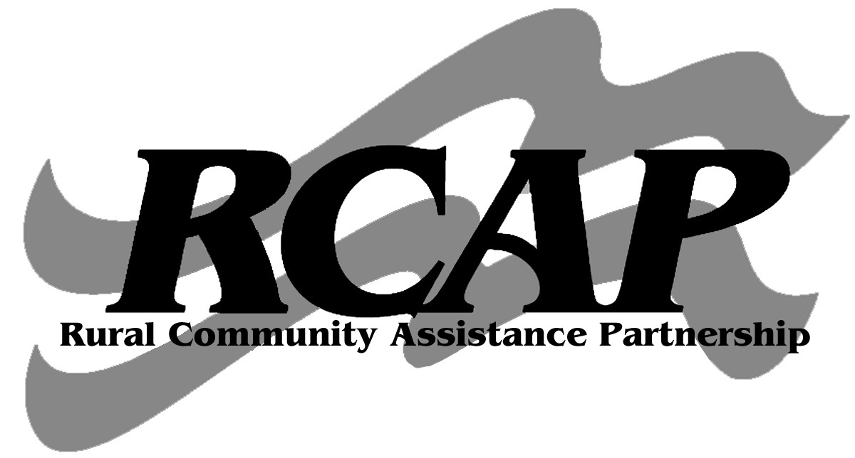
This publication is being distributed under the auspices of Rural Community Assistance Partnership.


Contents
Planning Template 2
Introduction 2
How to use the template 2
The requirement for an emergency response plan 2
Section 1. System Information 3
Section 2. Chain of Command – Lines of Authority 4
Section 3. Events that Cause Emergencies 5
Section 4. Emergency Notification 6
Section 5. Effective Communication 10
Section 6. Response Actions for Specific Events 11
Section 7. Alternative Water Sources 17
Section 8. Returning to Normal Operation 18
Section 9. Plan Approval 19
Section 10.Certificate of Completion 20

Planning Template


Introduction
Preparing an emergency response plan is an essential part of managing a drinking water system. Rural Community Assistance Partnership, Inc has developed this template for public water systems serving 3,300 population or fewer to help them develop such plans.
How to use the template

Developing an emergency response plan can take a lot of time and effort. The purpose of this document is to make the job easier and help create a plan that works for your water system. The document is intended for use by any water system and may be modified to fit the specific needs of each system. This document can be used as a starting point based on what is relevant for the type, size, and complexity of the system.
The template is just a guide; you may modify it in any way that works for your system – add sections, take them out, or rearrange them if you wish. You may also use a completely different format for your plan if you find one that works better for your system.
Since this document may contain sensitive information, do not submit it to USDA/RD and make sure to keep it stored in a safe and secure location. It is recommended you have one copy stored on-site and one off-site to ensure the document is available in the event you are unable to access your offices or facilities. The document is available electronically on the web at: http://www.rcap.org
The requirement for an
emergency response plan

The United States Department of Agriculture, Rural Development (USDA/RD) is requiring that all systems that receive USDA/RD funding must complete a Security Vulnerability Assessment (SVA) and Emergency Response Plan (ERP). In addition to the USDA/RD requirements, the preparation of a SVA and ERP will help improve the management of the water system and will increase the system’s ability to respond to emergencies.
This guidance document can be used to help meet the requirement for developing an emergency response program for a water system serving 3,300 population or fewer. Other methods or formats can also be used to meet the emergency response program requirement.

Section 1.
System Information

Keep this basic information easily accessible to authorized staff for emergency responders, repair people, and the news media.
System information
System Identification Number
System Name and Address
Directions to the System
Basic Description and Location of System Facilities
Location/Town
Population Served and Service Connections from Division of Drinking Water Records | ________ people | ________ connections
System Owner
Name, Title, and Phone Number of Person Responsible for Maintaining and Implementing the Emergency Plan |  |  | _______________ Phone  _______________ Cell  _______________ Pager
Section 2.
Chain of Command – Lines of Authority

The first response step in any emergency is to inform the person at the top of this list, who is responsible for managing the emergency and making key decisions.
Chain of command – lines of authority
Name and Title | Responsibilities During an Emergency | Contact Numbers

Section 3.
Events that Cause Emergencies

The events listed below may cause water system emergencies. They are arranged from highest to lowest probable risk.
Events that cause emergencies
Type of Event | Probability or Risk  (High-Med-Low) | Comments

Section 4.
Emergency Notification

Notification call-up lists - Use these lists to notify first responders of an emergency.
Emergency Notification List

Organization or Department | Name & Position | Telephone | Night or Cell Phone | Email
Local Law Enforcement
Fire Department

Emergency Medical Services
Water Operator
(if contractor)
Primacy Agency Contact
Hazmat Hotline

Interconnected Water
System
Neighboring Water System (not connected)
RCAP Contact

Rural Water Contact

Priority Customers

Organization or Department | Name & Position | Telephone | Night or Cell Phone | Email
Hospitals or Clinic(s)
Public or Private Schools
Wastewater Treatment Plant
Adult Care Facility

State, Federal or Tribal Notification List

Organization or Department | Name & Position | Telephone | Night or Cell Phone | Email
State or Tribal Police

Regulatory Agency State/Federal/Tribal

Authorized Testing Laboratory

Service / Repair Notifications

Organization or Department | Name & Position | Telephone | Night or Cell Phone | Email
Electric Utility Co.
Electrician
Gas/Propane Supplier
Water Testing Lab.
Sewer Utility Co.
Telephone Co.
Plumber
Pump Supplier
“Call Before You Dig”
Rental Equipment Supplier
Chlorine Supplier
Well Drilling Co.
Pipe Supplier

Media Notification List

Organization or Department | Name & Position | Telephone | Night or Cell Phone | Email
Newspaper - Local
Newspaper – Regional/State/Tribal
Radio
Radio
TV Station

Notification procedures
Notify water system customers of potential water shortage
Who is Responsible:
Procedures:

Alert local law enforcement, state, federal, or tribal drinking water officials, and local health agencies
Who is Responsible:
Procedures:

Contact service and repair contractors
Who is Responsible:
Procedures:

Contact neighboring water systems, if necessary
Who is Responsible:
Procedures:

Procedures for issuing a health advisory
Who is Responsible:
Procedures:

Other procedures as necessary
Who is Responsible:
Procedures:

Section 5.
Effective Communication

Communication with customers, the news media, and the general public is a critical part of emergency response.
Designated public spokesperson
Designate a spokesperson (and alternate) and contact your local primacy agency for delivering messages to the news media and the public.
Designate a spokesperson and alternates
Spokesperson | Alternate

Health advisories
During events when water quality and human health are in question, it may be necessary to issue a health advisory that gives advice or recommendations to water system customers on how to protect their health when drinking water is considered unsafe. These advisories are issued when the health risks to the consumers are sufficient, in the estimation of the water system, state or tribal, or local health officials, to warrant such advice.
Health advisories usually take the form of a drinking water warning or boil water advisory. Communication during these times is critical. Health advisories should always be well thought out and provide very clear messages.
The U.S. Environmental Protection Agency has put together a number of tools, including fact sheets, brochures, forms, and templates to help prepare for a health advisory. These are on the web at: http://www.epa.gov/safewater/pn.html

Section 6.
Response Actions for Specific Events
In any event, there are a series of general steps to take:
- Analyze the type and severity of the emergency;
- Take immediate actions to save lives;
- Take action to reduce injuries and system damage;
- Make repairs based on priority demand, and
- Return the system to normal operation.
The following tables identify the assessment, set forth immediate response actions, define what notifications need to be made, and describe important follow-up actions.
- Power outage

Assessment
Immediate Actions
Notifications
Follow-up Actions

- Distribution line break

Assessment
Immediate Actions
Notifications
Follow-up Actions

- Chlorine treatment equipment failure

Assessment
Immediate Actions
Notifications
Follow-up Actions

- Treatment equipment

Assessment
Immediate Actions
Notifications
Follow-up Actions

- Source pump failure

Assessment
Immediate Actions
Notifications
Follow-up Actions

- Microbial (coliform, E. coli) contamination

Assessment
Immediate Actions
Notifications
Follow-up Actions

- Chemical contamination

Assessment
Immediate Actions
Notifications
Follow-up Actions

- Vandalism or terrorist attack

Assessment
Immediate Actions
Notifications
Follow-up Actions

- Reduction or loss of water in the well

Assessment
Immediate Actions
Notifications
Follow-up Actions

- Drought

Assessment
Immediate Actions
Notifications
Follow-up Actions

- Flood

Assessment
Immediate Actions
Notifications
Follow-up Actions

- Earthquake

Assessment
Immediate Actions
Notifications
Follow-up Actions

- Hazardous materials spill in vicinity of sources or system lines

Assessment
Immediate Actions
Notifications
Follow-up Actions

- Electronic equipment failure

Assessment
Immediate Actions
Notifications
Follow-up Actions

- Cyber attack

Assessment
Immediate Actions
Notifications
Follow-up Actions

- Other

Assessment
Immediate Actions
Notifications
Follow-up Actions

Section 7.
Alternative Water Sources

Intertie to adjacent water supply system
Water Systems Within One-Quarter Mile of our System | Feasibility of Connecting

Alternate source(s) of water
Alternative Sources | Names | Phone | Availability | Is the Water Safe for Drinking?
Bottled water Suppliers for potable water use

Tanker trucks in the area available to deliver bulk water for non potable use

Section 8.
Returning to Normal Operation
Returning to normal operations
Action | Description and Actions

Section 9.
Plan Approval
Plan approval
This plan is officially in effect when reviewed, approved, and signed by the following people:
Name/Title | Signature | Date

Section 10.
Certificate of Completion

I certify to the United States Department of Agriculture, Rural Development (USDA/RD) that this community water system has completed an Emergency Response Plan (ERP) that incorporates the results of the Security Vulnerability Assessment (SVA) completed for the system.
I certify that this document was prepared under my direction or supervision. I am aware that there are significant penalties for submitting false information (Safe Drinking Water Act (42U.S.C. 300f et seq.).
Mail the completed certificate only (do not send your SVA or ERP) to the appropriate USDA Rural Development office.

Public Water System ID Number:
System Name:
Address:
Print Name of Person Authorized to Sign this Certification on behalf of the System:
 |  |  |  |  |  |  |  | Title:
Signature:
Phone: |  |  |  |  |  | Fax: |  |  |  | Email:

Received Technical Assistance from the following:
- Rural Community Assistance Partnership
(CRG, Great Lakes RCAP/WSOS, MAP, RCAC, RCAP Solutions, Southeast RCAP)

- Rural Water Association

Completing the following:
- Security Vulnerability Assessment
- Emergency Response Plan

Disclaimer

This document contains information on how to plan for protection of the assets of your water system. The work necessarily addresses problems in a general nature. You should review local, state, tribal (if applicable), and federal laws and regulations to see how they apply to your specific situation.

Knowledgeable professionals prepared this document using current information. The authors make no representation, expressed or implied, that this information is suitable for any specific situation. The authors have no obligation to update this work or to make notification of any changes in statutes, regulations, information, or programs described in this document. Publication of this document does not replace the duty of water systems to warn and properly train their employees and others concerning health and safety risks and necessary precautions at their water systems.

Rural Community Assistance Partnership, Inc. assumes no liability resulting from the use or reliance upon any information, guidance, suggestions, conclusions, or opinions contained in this document.

Rural Community Assistance Partnership, Inc.
1522 K Street, N.W., Suite 400
Washington, D.C. 20005
888/321-7227

