Emergency Response
Planning Guide for Public
Drinking Water Systems
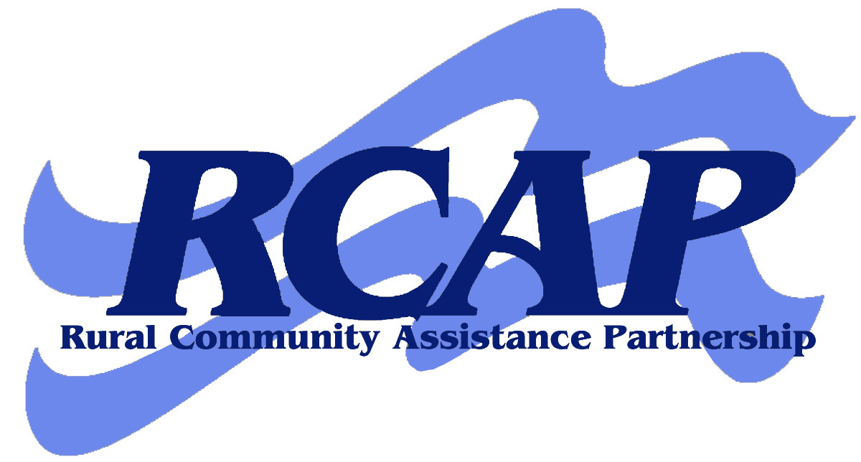




Rural Community Assistance Corporation
www.rcac.org





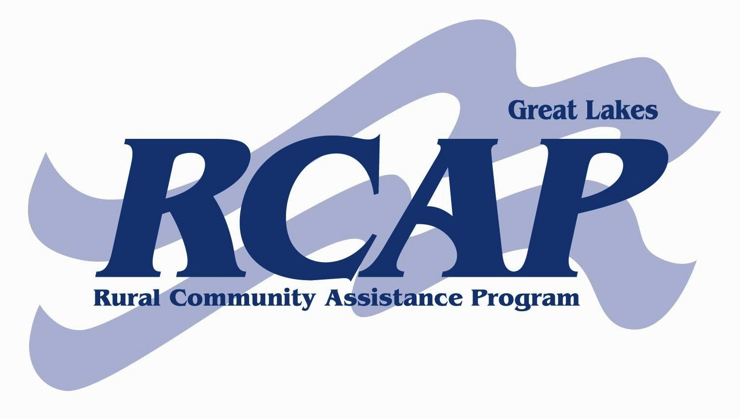



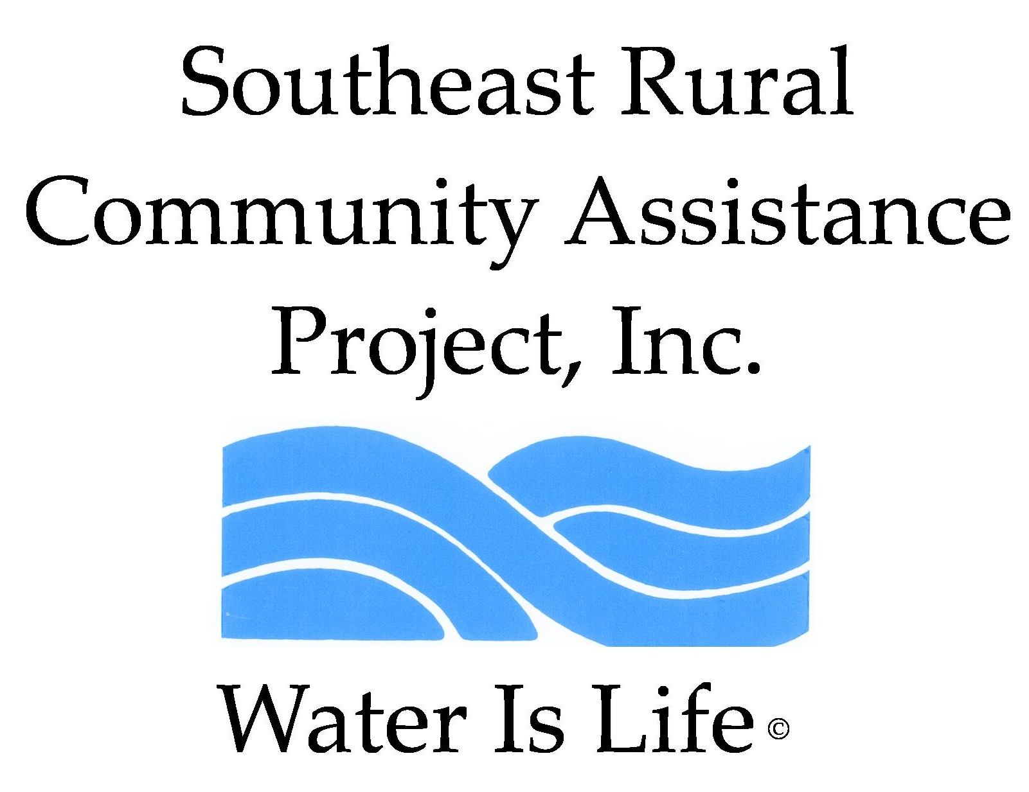

Produced for the Rural Community Assistance Partnership (RCAP) National Network
by Rural Community Assistance Corporation, Western RCAP
RCAP Safety and Security Education Program

Emergency Response
Planning Guide for Public
Drinking Water Systems

RCAP Regional Offices:
If you need technical assistance to complete your Emergency Response Plan, please contact one of our regional offices listed below.

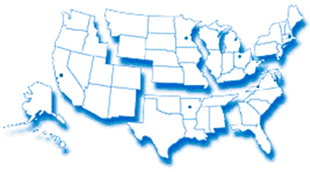
Western RCAP
Midwest RCAP
Great Lakes RCAP
Southern RCAP
RCAP National Office
Southeast RCAP
Northeast RCAP
Regional Offices | Contact Number | Web Address
RCAP National Office | 888/321-7227 | www.rcap.org
Western RCAP | 916/447-2854 | www.rcac.org
Southeast RCAP | 866/928-3731 | www.southeastrcap.org
Great Lakes RCAP | 800/775-9767 | www.glrcap.org
Southern RCAP | 479/443-2700 | www.crg.org
Northeast RCAP | 800/488-1969 | www.rcapsolutions.org
Midwest RCAP | 952/758-4334 | www.map-inc.org

This material is based upon work supported in part under a grant by the Rural Utilities Service, United States Department of Agriculture. Any opinions, findings, and conclusions or recommendations expressed in this material are solely the responsibility of the authors and do not necessarily represent the official views of the Rural Utilities Service. Additional funding provided by U.S. Department of Health and Human Services and revised by RCAC (August 2005) based on materials developed by the Washington State Department of Health, Training and Outreach Section, Division of Drinking Water.

For additional copies of this publication, call 888/321-7227or visit RCAP’s web site
at www.rcap.org.

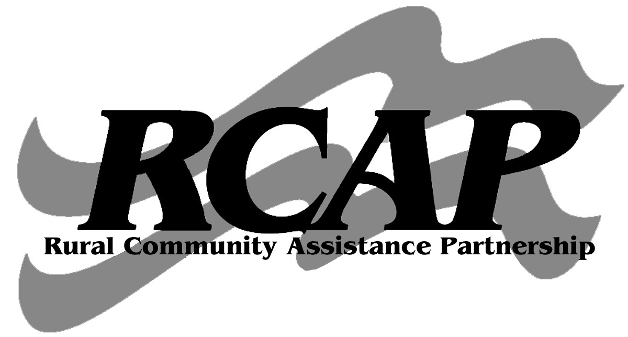
This publication is being distributed under the auspices of Rural Community Assistance Partnership.


Contents
Guidance and Instructions 2
Introduction: Protecting public health 2
The requirement for an Emergency Response Plan 2
How to use this document 3
Section 1. System Information 3
Section 2. Chain of Command – Lines of Authority 5
Section 3. Events that Cause Emergencies 7
Section 4. Emergency Notification 10
Section 5. Effective Communication 14
Section 6. Response Actions for Specific Events 16
Section 7. Alternative Water Sources 23
Section 8. Returning to Normal Operation 24
Section 9. Plan Approval 25
Section 10. Certificate of Completion 26

Guidance and Instructions


Introduction:
Protecting public health

Safe and reliable drinking water is vital to every community. Preparing an emergency response plan (ERP) is an essential part of managing a drinking water system. Rural Community Assistance Partnership has developed this guidance and instruction manual for public water systems serving 3,300 population or fewer to help them develop such plans.
Most public water systems have had routine operating emergencies such as pipe breaks, pump malfunctions, coliform contamination, and power outages. These are manageable if the water system has an emergency response plan that can be put into action quickly.
More serious non-routine emergencies may result from intentional acts of sabotage, chemical spills, floods, earthquakes, windstorms, hurricanes, and tornados or droughts. These can drastically affect the system and the community that depends on it.
Each emergency has unique effects on different parts of a water system. Floods can cause widespread bacterial contamination. Earthquakes, hurricanes, and tornados can damage sources and distribution systems, and storms can disrupt power supplies. The common element is that each emergency may threaten the system’s ability to deliver safe and reliable drinking water.
Emergency response planning is a process by which water system managers and staff explore vulnerabilities, make improvements, and establish procedures to follow in an emergency. It is also a process that encourages people to form partnerships and get to know one another. Preparing a response plan and practicing it can save lives, prevent illness, enhance system security, minimize property damage, and lessen liability.
The requirement for an
emergency response plan

The United States Department of Agriculture, Rural Development (USDA/RD) is requiring that all systems that receive USDA/RD funding must complete a Security Vulnerability Assessment (SVA) and Emergency Response Plan (ERP). In addition to the USDA/RD requirements, the preparation of a SVA and ERP will help improve the management of the water system and will increase the system’s ability to respond to emergencies.
This guidance document can be used to help meet the requirement for developing an emergency response program for a water system serving 3,300 population or fewer. Other methods or formats can also be used to meet the emergency response program requirement.
How to use this document

Developing an emergency response plan can take a lot of time and effort. The purpose of this document is to make the job easier and help create a plan that works for your water system. The document is intended for use by any water system and may be modified to fit the specific needs of each system. This document can be used as a starting point based on what is relevant for the type, size, and complexity of the system.
The document has two manuals with identical structure. RCAP Emergency Response Planning Guide discusses important emergency response planning elements and provides instructions and examples to help complete RCAP ERP template, which is a template for creating your own plan. You can also use RCAP ERP Guide as an educational tool to help system staff understand the key components needed for a well thought-out plan. The document is available electronically on the web at: www.rcap.org
The RCAP ERP template is just a guide; you may modify it in any way that works for your system – add sections, take them out, or rearrange them if you wish. You may also use a completely different format for your plan if you find one that works better for your system.
Since the completed Emergency Response Plan may contain sensitive information, do not submit it to USDA/RD and make sure to keep it stored in a safe and secure location. It is recommended you have one copy stored on-site and one off-site to ensure the document is available in the event you are unable to access your offices or facilities.


Section 1.
System Information

In any emergency, a water system needs to have basic information available for both system personnel, and external parties such as emergency responders, repair people, the media, and others. The information needs to be clearly formatted and readily accessible so system staff can quickly find it and provide it to those who may be involved in responding to the emergency. Providing this information in advance is an important step in forming partnerships.
Basic information that should be presented in the emergency response plan are the system’s ID number, system name, system address or location, directions to the system, population served, number of service connections, system owner, and information about the person in charge of managing the emergency. See the example of how to present the information on the next page.
Example: System information
System Identification Number | 19900
System Name and Address | XYZ Water System  1000 Anywhere Street  XYZ, WA 98000
Directions to the System | North on route 6 to exit 88. Take right and head west for 2.9 mile to XYZ drive. Take a left onto XYZ drive and go 0.5 miles. Office is on the left. Pump-house and treatment facilities are 0.2 miles past office on the right.
Basic Description and Location of System Facilities | The XYZ water system has two groundwater wells of 180’ and 223’ depth and one surface water source with treatment. The wells pump through the pump-house and chlorination treatment facilities into two storage reservoirs, one at the north end and one at the south end of the system, which feed the distribution system. The north reservoir is located at the end of J street and the south reservoir is located at the intersection of Olive Street and 2nd Street.
Location/Town | XYZ
Population Served and Service Connections from Division of Drinking Water Records | 650 people | 225 connections
System Owner | Town of XYZ
Name, Title, and Phone Number of Person Responsible for Maintaining and Implementing the Emergency Plan | Marsha Ready  Manager |  | (360) 232-2323 Phone  (360) 790-2323 Cell  (360) 799-8999 Pager

The information in this table is a starting point. The system may have unique circumstances, or it may have a geographical range that expands over a large area requiring additional information. In any case, make sure the information is clear, accurate, and easily located.
In addition to this basic information, the water system should have a detailed map of the distribution system and a plan for how to communicate if phones and radios don’t work. For example, arrange places to meet and designate less technical ways to share and distribute information.
Section 2.
Chain of Command – Lines of Authority

When an emergency occurs, there can be confusion, lack of coordination, and poor communication. Timely and effective response can minimize the effects of an emergency. Often, the initial response sets the tone for the entire emergency.
Having a chain of command that defines clear lines of authority and responsibilities for system personnel during an emergency speeds up response time and helps eliminate confusion. System personnel need to know who to report the emergency to, who manages the emergency, who makes decisions, and what their own responsibilities are.
The first response step in any emergency is to notify the person at the top of the chain of command – the person responsible for managing the emergency and making key decisions. This lead person will assess the situation and initiate a series of response actions based on the type and severity of emergency. Small systems may have only one or two people in the chain of command. Some small systems may have only one person, usually the water system operator, in their chain of command. In these cases make sure each responsibility is clearly defined so the person does not forget it during an emergency.
In addition to an individual having the lead responsibility, other key responsibilities that should be assigned to system personnel include the following tasks:
- Handle incoming phone calls and administrative support;
- Provide information to the public and media;
- Contact the customers;
- Assess the system’s facilities and operations in the field; and
- Organize and carry out repairs.

Example: Chain of command – lines of authority
Name and Title | Responsibilities During an Emergency | Contact Numbers
Marsha Ready  Water System Manager | Responsible for overall management and decision making for the water system. The Water System Manager is the lead for managing the emergency, providing information to regulatory agencies, the public and news media. All communications to external parties are to be approved by the water system manager. | Phone:  (xxx) 232-2323  Cell:  (xxx) 790-2320  Pager:  (xxx) 799-8999
John J. Dunbar  Water System Operator | In charge of operating the water system, performing inspections, maintenance and sampling and relaying critical information, assessing facilities, and providing recommendations to the water system manager. | Phone:  (xxx) 232-2333  Cell:  (xxx) 790-2329  Pager:  (xxx) 799-8998
Freddy Filter  Water Treatment Plant Operator | In charge of running water treatment plant, performing inspections, maintenance and sampling and relaying critical information, assessing facilities, and providing recommendations to the water system operator or manager. | Phone:  (xxx) 232-2343  Cell:  (xxx) 790-2327  Pager:  (xxx) 799-8997
Mary Marshall  Office Administrator | Responsible for administrative functions in the office including receiving phone calls and keeping a log of events. This person will provide a standard carefully pre-scripted message to those who call with general questions. Additional information will be released through the water system manager. | Phone:  (xxx) 232-2353  Cell:  (xxx) 790-2326  Pager:  (xxx) 799-8996
Jerry Mander  Field Staff | Delivers door hangers and supports water system operator. | Phone:  (xxx) 232-2363  Cell:  (xxx) 790-2325  Pager:  (xxx) 799-8995
Section 3.
Events that Cause Emergencies

Why do emergencies happen? There are a variety of reasons including:
- Natural disasters;
- Accidents;
- Deliberate acts of vandalism or terrorism; and
- System neglect or deferred maintenance.
An emergency may affect the entire water system or only isolated sections. You should evaluate a variety of events regarding their potential effects on the water system and its infrastructure. Each type of event can cause different types of damage to system components or contamination resulting in a disruption in service. These evaluations should be reflected in the water system’s Security Vulnerability Assessment and procedures for responding to specific events that are discussed later in this document.
Natural Disasters
Consider common natural disasters when developing an emergency response plan, including:
Earthquakes: Damage resulting from the earth shifting along geologic faults resulting in shaking and settling of the ground can cause severe structural damage to virtually all water system facilities, including sources, transmission and distribution lines, storage reservoirs, and pump-houses.
Emergency response plans should evaluate what facilities are at risk during an earthquake, what can be done to mitigate impacts (for example, strapping down reservoirs), and what actions can be taken to respond to such an event. It is also important to have backup communication plans, because radios and cell phones may not work after an earthquake.
Hurricanes or tornados: Hurricanes or tornados can cause a wide range of emergency situations over large areas. Each water system should evaluate its ability to withstand the potential effects of a hurricane or tornado.
Floods: Can cause widespread contamination as turbid waters carry bacteria that can overflow sources, transmission lines, treatment facilities, and pumping facilities. Floods can also ruin electrical components and telemetry systems.
It is important for a water system to assess its vulnerability to flooding. Consider damage to roads and bridges where distribution or transmission lines are located. Washout of roads or bridges not only damages pipes but also can interfere with repair. If the risk for a flood is high, the water system should plan for and consider mitigating actions to protect facilities and equipment.
Another consideration is identification of alternative transportation routes to get in and out of the area.
High winds: Wind storms often generate winds in excess of 50 miles an hour or greater from time-to-time. These storms often disrupt power and damage water system facilities.
Ice Storms: These fierce storms have the power to cause major power outages and freeze water pipes. The ice slows the ability of crews to get to areas to make repairs.
Drought: During normal years, peak summer demands can double and even triple water use. These same demands during low water years can lead to water shortages. Drought severity is affected by a combination of environmental factors, all of which change over time, including rainfall, temperature, snow pack, and length of drought. Compared to other natural disasters, drought has a relatively slow onset and is easier to anticipate.
Waterborne diseases: Organisms such as Giardia and Cryptosporidium can contaminate water supplies and cause waterborne diseases.
Human-caused events: Human-caused events that can result in a water system emergency include chemical spills, vandalism, terrorism, cyber-attack, fires, construction accidents, and basic neglect of maintaining the system.
Vandalism: Vandalism is generally a spur-of-the-moment act using materials at hand rather than pre-planned or pre-meditated activities. Vandals often break into systems, damage facilities, and paint graffiti. These acts are relatively easy to prevent by enhancing security, increasing lighting, installing locks on doors and hatches, and putting up security fencing.
Terrorism: Acts of terrorism are conducted by someone whose intent is to instill fear or induce harm to people and facilities. Acts of terrorism are a very real threat in America. Even though it may seem unlikely, it would take only one well-staged event to undermine confidence in drinking water safety. Being prepared and knowing what to look for are crucial elements of preventing an attack on the system.
There are many potential threats to drinking water systems, including chemical, biological or radiological contamination as well as damage to infrastructure and computer systems. In most cases, contamination using biological or chemical agents would cause the most concern for a drinking water system. Although it would be difficult to contaminate a large water supply effectively with these agents or cause major damage, the possibility should not be taken lightly. The threat is real, and drinking water systems need to enhance security around facilities and be prepared to respond.
System neglect: System neglect, often referred to as deferred maintenance, is a major cause of emergencies. System components that are aging and need replacement go without attention for so long that they fail, causing an emergency. Drinking water systems need to evaluate facilities continuously and replace them before a massive failure occurs. In one case, a drinking water system continuously put off repairing its major transmission line that traversed a hillside in town. The line finally failed and caused an immense slide, destroying a number of homes and causing significant damage.
Cross Connections: A cross connection is an actual or potential physical connection between a public water system and any source of non-potable liquid, solid, or gas that could potentially contaminate water supply through a backflow process. Cross connections usually occur unknowingly when someone makes a connection in the system. Backflow is the reverse flow of water or other substances into the public water system. Under backflow conditions, unprotected cross-connections can provide a path for biological, chemical, or physical contaminants to enter the water supply. These contaminants can lead to waterborne disease outbreaks, chemical poisonings, and sometimes death. Backflow usually occurs when there is a loss of pressure somewhere in the system causing water to reverse its flow direction.
Construction accidents: Construction accidents sometimes fall into the category of a routine operating emergency. An example is when a contractor damages a water line and the system needs to be shut down for repair. If the response is not timely and effective, this kind of incident can turn into a serious emergency. The system may lose pressure, resulting in serious backflow incidents that contaminate the water. The utility must be aware of construction in and around the system and be prepared to respond quickly to an accident if it happens.
Chemical spills: Many chemicals that are routinely transported can harm humans directly or by contaminating air or water. No drinking water system is safe from a hazardous chemical spill and the resulting contamination. Spills can come from motor vehicles, trains, airplanes, boats, or fixed containers. They can occur at any time without warning, and many solvents are able to leach through PVC pipes. Water systems should evaluate the potential for chemical spills in their wellhead protection programs and use that information for emergency response planning.
A water system may be vulnerable to many natural and man-made disasters. Understanding these vulnerabilities is an important part of emergency planning. In preparing a plan consider the probability of an event and its likely effect on the water system. Then focus on the actions needed to reduce impacts, and respond in a timely and effective manner.
Example: Events that cause emergencies
Type of Event | Probability or Risk  (High – Med – Low) | Comments
Earthquake | High | Had minor earthquake damages in February 2005 quake.
Hurricane or Tornado | High | Are an annual threat.
Flood | Low | System not located in an area vulnerable to flooding.
High winds/Thunderstorms | High | System is vulnerable to high wind events. Power is disrupted.
Ice Storm | Med | Minor damage caused in December 1996. Broken pipes and damaged pump house.
Drought | Med | Need to plan for decrease in well yield during dry summers.
Terrorism | Low | Need to be trained on suspicious activity.
Construction Accident | Med | Construction crews often hit pipes.
Section 4.
Emergency Notification

During most emergencies, it will be necessary to notify a variety of parties quickly.
Preparation for such notification has three essential components:
- Assigning responsibility to oversee and carry out the notifications;
- Assembling comprehensive call-up lists with names and contact numbers; and
- Writing out procedures for quickly disseminating information to appropriate parties.
If you don’t have readily available notification information or the means to deliver it, you run the risk of losing valuable response time. This may make the difference between minor and major damages. Having well-formed partnerships will help during these times.
In addition to phone, email, and media for notification, consider forming partnerships with local community groups, emergency planning committees, scout troops, and school clubs to assist in delivering information when needed.
Water system managers from relatively small systems should poll customers to determine the best method of communicating. It is also a good idea to give customers some general safety information regarding what to do in case of an emergency before one happens.
Notification call-up list
Call-up lists should be comprehensive, including local law enforcement, local primacy agency, department that handles spill response, local mayors and city officials, local health officials, safety officials, local emergency responder, water testing laboratories, and service/repair providers. A list of priority customers, such as hospitals, nursing homes, clinics, and schools should also be maintained for immediate notification. The ERP Template has comprehensive lists to assist you. You may modify them as necessary.
Notification procedures
Once you have your list completed it is important to describe the procedures you will use to distribute information quickly to appropriate parties. These procedures describe how to make notifications to specific parties, who is responsible for conducting the notifications, who assists in the notifications, and what methods are used to complete them. In addition, specific procedures on how to issue a health advisory should be defined so that you are prepared to do so in the event that your water supply is unsafe for drinking or use. Issuing a health advisory should be done by the water system when there is reason to believe the water is unsafe. Local primacy agency staff members are available for consultation in making this decision.
Other procedures to define include:
- Notifying system personnel who may be on-call or off-duty;
- Notifying customers, priority customers, and industrial customers;
- Alerting local law enforcement, drinking water officials, local health officials, and water testing laboratories when appropriate;
- Contacting service and repair contractors;
- Contacting neighboring water systems for assistance, if necessary; and
- Arranging for alternative water supplies such as bottled water.
Example: Procedures for notifying system customers of potential water shortage
Who is Responsible: | The water system manager is ultimately responsible for making the decision to notify customers regarding a potential water shortage and the need for water use restrictions. The water system manager should consult with field staff to make the decision. Once the decision is made procedures for notification will be initiated.
Procedures: | - Water system manager confers with key staff to verify problems.  - Water system manager organizes staff to develop the message to be delivered to the customers.  - Water system manager consults with state drinking water staff regarding the problem.  - Water system manager with assistance from staff prepares door hangers, signs and radio message.  - Water system operator continues to investigate problem and make repairs as necessary.  - The water shortage notification will be distributed by:  - Field staff placing “water shortage notices” on doors and along travel routes.  - Staff will place signs on main travel routes into the community.  - Water system manager contacts radio station and requests issuance of the water shortage notice and request to curtail water use.  - Administrative support person will provide a pre-scripted message to phone callers and log in each phone call.  - Water system operator continuously updates the water system manager on water shortage.  - Once water shortage is resolved, re-notify customers.

Example: Alert local law enforcement, state, federal, or tribal drinking water officials, and local health division
Who is Responsible: | John Doe, operator and president
Procedures: | President will notify local primacy agency concerning emergencies and seek guidance on consulting with other agencies.

Example: Contact service and repair contractors
Who is Responsible: | John Doe, operator and president
Procedures: | Contact ABC Industries to authorize repairs and conduct work and investigation of water issues

Example: Contact neighboring water systems, if necessary
Who is Responsible: | John Doe
Procedures: | Contact Mountain River water system, Jim Ready 555/332-5128

Example: Procedures for issuing a health advisory
Who is Responsible: | John Doe
Procedures: | Contact local primacy agency, ask Mark Neon for guidance and requirements 555/265-6384.

Other procedures, as necessary
Who is Responsible: | John Doe
Procedures: | Contact DeWayne Airs to mobilize local volunteers to notify residents and check on facilities 555/769-7037 or Ernie Brown 555/664-0833
Section 5.
Effective Communication

Effective communication is a key element of emergency response. Make sure you have a well thought out communications strategy in place as part of your emergency response plan. If you haven’t planned ahead by the time a crisis hits, it’s too late. How you communicate with your employees, customers, and the media can affect the outcome of the situation.
Developing partnerships with others in your local emergency response network, establishing relationships with your customers and the media, and creating communication tools such as fact sheets and media releases ahead of time will help you communicate efficiently and successfully during a crisis. For example, establish positive media relations before an emergency. Make an effort to meet with reporters in your local area to share information about your water system and how they could receive information should an emergency occur. Also contact your local emergency response organization if one exists (e.g., the Local Emergency Planning Committee) and determine what assistance they can provide during an emergency.
During an emergency, the media, your customers, and others will have many questions. Be prepared by organizing basic facts about the crisis and your water system. Assemble a team of players quickly, including a main spokesperson and one or more people to answer customer calls.
Develop key messages to use with the media that are clear, brief, and accurate. Make sure your messages are carefully planned and have been coordinated with local and state officials. If your messages are different you’ll want to know that and be prepared to explain why.
Make sure field and office staff know how to deal with the media and questions from customers and the public. It may be necessary to establish protocols for both field and office staff to defer questions to the spokesperson respectfully.
Small water systems that have limited staff should remember that your local state, federal or tribal primacy agency is available to assist in developing and communicating messages to the media and the public. This can be especially helpful when staff need to focus on other tasks.
Communication Tips
Do:
- Be prepared;
- Designate a spokesperson;
- Provide complete, accurate, and timely information;
- Tell the truth;
- Express empathy;
- Acknowledge uncertainty and offer to get back with more information later; and
- Document your communications.

Do not:
- Speculate on the cause or outcome of an incident;
- Blame or debate;
- Minimize or brush off concerns of customers; and
- Treat inquiries from interested parties as an annoying distraction from the real business of emergency response.

Example: Designate a spokesperson and alternate
Spokesperson | Alternate
Marsha Ready, Manager | Mary Marshall, Office Admin.

Health Advisories
During events when water quality and public health are in question, it may be necessary to issue a health advisory. The term “Health Advisory” means advice or recommendations to water system customers on how to protect their health when drinking water is considered unsafe. These advisories are issued when the health risks to the consumers are sufficient, in the estimation of the water system or, state or tribal, or local health officials, to warrant such advice.
Health advisories usually take the form of a drinking water warning or boil water advisory. Communication during these times is critical. Your local primacy agency staff is committed to working closely with water systems to determine if an advisory is needed. Health advisories should always be well thought out and provide very clear messages.
The U.S. Environmental Protection Agency has put together a number of tools, including fact sheets, brochures, forms, and templates to help prepare for a health advisory. These are on the web at: http://www.epa.gov/safewater/pn.html
Health advisories can be challenging and time consuming for the water system and public health partners. They are also inconvenient for water system customers. However, these advisories are necessary in order to protect public health. In determining whether to issue a health advisory, there are many things to consider and questions to answer, usually in a short time period. This is another important reason that water systems should form partnerships in advance of these events. If there are well-formed partnerships, it will be much easier to obtain information, make decisions, and get the information out to the public.

Section 6.
Response Actions for Specific Events

Develop a detailed response plan for each type of emergency event that the system may experience. In any event there are a series of general steps that a water system should take:
- Analyze the type and severity of the emergency.
- Take immediate actions to save lives.
- Take action to reduce injuries and system damage.
- Make repairs based on priority demand.
- Return the system to normal operation.
Knowing the various elements of emergency response planning and keeping in mind these general steps will help you develop response actions for specific events.
Establishing response actions for specific events
There are numerous events which may cause an emergency that are dictated by the system’s size, complexity, type of source, and geographic location. As discussed before, likely causes of emergencies that a system should consider are power outages, transmission or distribution line breaks, chlorine treatment failure, surface water treatment malfunction, source pump failures, microbial (coliform, E. coli) contamination, chemical contamination, acts of terrorism, vandalism, loss of water in the well, drought, floods, ice storms, earthquakes, hurricanes, and hazardous spills in the vicinity of sources or distribution lines. In any of these situations your priority is the protection of people using the water. Be observant of what is going on around you, and if you suspect vandalism or terrorism, contact local law enforcement and make every effort to preserve evidence.
These are only starting points, since each system is unique and may encounter additional situations that are important to be prepared for. Use partnerships to assist in this effort. The following table presents a way to identify an event, summarize the assessment, set forth immediate response actions, define what notifications need to be made, and describe important follow-up actions.
Do not attempt to conduct a damage assessment until it is safe to do so.

Example: Power outage
Assessment | The XYZ water system is vulnerable to power outages, experiencing an average of three outages per year that last several hours. The system does not have a back-up generator but has a connection so that a generator can be rented and plugged into the system. Most of the time, storage is able to supply the system for several hours until power is restored.
Immediate Actions | - Assess whether the outage is likely to last more than 6 hours. If no, be on alert for changing conditions and monitor storage tanks. If yes, complete the following steps:  - Call on availability of back-up generator at JJ’s Rentals.  - Obtain generator if available.  - Connect generator to system and resume operations.  - Implement water shortage response actions to inform customers to cut back on water usage until power is restored.
Notifications | - Power Company – let them know that a public water system is experiencing an outage and the generator will be turned on until power is restored.  - JJ’s Rentals – obtain generator.  - Customers – cut back on water usage until power is restored.
Follow-up Actions | - Turn off and disconnect back-up generator.  - Return system to general power supply.  - Inspect reservoirs and pumping facilities to ensure proper operation.  - Return generator to JJ’s Rentals.  - Update ERP as needed.

Example: Distribution line break

Assessment | Operator and ABC Industries
Immediate Actions | Direct ABC Industries to fix the line break.
Notifications | Residents affected by line break.
Follow-up Actions | Disinfection and sampling of water line after placing it in service. Update ERP as needed.

Example: Chlorine treatment equipment failure
Assessment | Operator and ABC Industries
Immediate Actions | - Isolate equipment and repair or replace.  - In case of chlorine release, restrict access to area until completion of cleanup.  - Ensure cleanup is conducted by trained personnel only. Wear adequate personal protective equipment.  - Remove all combustible and flammable materials.  - Ventilate area.  - Consult MSDS before any clean up efforts begin.  - Once clean up is complete proceed with repair or replacement of equipment.  - Test for chlorine residual at normal sampling points, and in water storage.  - As indicated by tests, dose water in storage with chlorine, flush system, or both.
Notifications | Local government occupational safety and health agency and environmental authorities if spill occurs.  Local primacy agency if inadequate chlorine residual is found.
Follow-up Actions | Retest for residual chlorine and microbial contamination. Update ERP as needed.

Example: Treatment equipment
Assessment | Operator and ABC Industries
Immediate Actions | - Isolate equipment and repair or replace.  - Consult manufacturer’s guidance documents for equipment troubleshooting and repair options.  - Test treated water for normal treatment performance parameters  - If treated water is off-spec do not send to treated storage.
Notifications | Local primacy agency if inadequate treatment is found.  Public notification as per guidance from the local primacy agency, and in accordance of the Safe Drinking Water Act.
Follow-up Actions | Notify public as per guidance from the local primacy agency and send a copy to them in accordance with the Safe Drinking Water Act. Update ERP as needed.

Example: Source pump failure
Assessment | Operator and ABC Industries
Immediate Actions | Restart pump and check control panel for causes, have electrician review controls and pump starter, repair or replace pump if required.
Notifications | Residents if pump is down over 24 hours to reduce water usage.
Follow-up Actions | Notification of residents when pump is repaired and water service is back to normal. Update ERP as needed.

Example: Microbial (coliform, E. coli) contamination
Assessment | Operator and ABC Industries
Immediate Actions | - Conduct follow up sampling.  - Disinfect system through storage reservoirs and flushing system through blow offs/hydrants throughout the system.  - Measure for Chlorine residual and re-sample for bacteria.
Notifications | Public notification as per guidance by local primacy agency, and in accordance with the Safe Drinking Water Act.
Follow-up Actions | Send notice to local primacy agency in accordance with the Safe Drinking Water Act. Update ERP as needed.

Example: Chemical contamination
Assessment | Operator
Immediate Actions | Not very likely as well not located near road and chemicals are not transported in this area.
Notifications | Public notification as per guidance from the local primacy agency, and in accordance with the Safe Drinking Water Act.
Follow-up Actions | Send notice to local primacy agency to meet Safe Drinking Water Act. Update ERP as needed.

Example: Vandalism or terrorist attack
Assessment | Operator determines severity of the incident.
Immediate Actions | - Call County Sheriff’s Office.  - Notify local primacy agency if necessary.  - Assess damage and take necessary action; (a) Fix or repair damage (b) Provide additional protection against future actions (c) Mobilize volunteers to notify residents of vandalism to watch for future actions.
Notifications | Activate volunteer notification system if necessary.
Follow-up Actions | Completion of repairs, return system to normal. Update ERP as needed.

Example: Reduction or loss of water in the well
Assessment | Operator and ABC Industries
Immediate Actions | - Monitor well production and check for system leaks or increased demand on system that could cause well stress.  - Check water level in well through air line and record measurement and trends.
Notifications | Use volunteer to notify residents to curtail water usage to inside use only until problem is solved.
Follow-up Actions | Notify residents that water system is back to normal operation. Update ERP as needed.

Example: Drought
Assessment | - Operator reviews well production and system trends.  - Static water level measurements show declines in water levels in wells.
Immediate Actions | Curtail outside watering, notify residents of problems.
Notifications | Use volunteer to notify residents to curtail water usage to inside use only until problem is solved.
Follow-up Actions | System returns to normal by notifying residents. Update ERP as needed.
Example: Flood
Assessment | Operator determines severity of the incident.
Immediate Actions | - Once flood has receded, operator will assess flood damage.  - Operator and ABC Industries will repair facilities as needed.
Notifications | Activate volunteer notification system if necessary.
Follow-up Actions | Completion of repairs, return system to normal. Update ERP as needed.

Example: Earthquake
Assessment | The operator will assess all sources, transmission and distribution lines, storage facilities to determine severity of the incident.
Immediate Actions | - Inspect well and pump house equipment; wellhead for damage or evidence of contamination, piping, valves, meters for damage, chemical feed equipment function.  - Check for power; electrical panels for damage/fire. Current/voltage imbalance at pump motor, loss of phase at pump motor.  - Determine if adequate pressure exists. Walk buried water lines looking for wet spots.  - Collect water samples for coliform contamination and disinfectant residual throughout the system.  - Check storage facility for leaks, foundation cracks, broken or loose rivets or welds, check ladder before using it.  - Check water level and gauge accuracy.
Notifications | Contact board president and update on damage assessment.
Follow-up Actions | Completion of repairs, return system to normal. Update ERP as needed.

Example: Hazardous materials spill in vicinity of sources or system lines
Assessment | Operator or Woodsy Fire Distinct
Immediate Actions | - This type of incident would be rare as hazardous materials are not transported within this area.  - Would seek guidance from Woodsy Fire District.
Notifications | Hazmat Team will determine severity of the leak and the need to contact others.
Follow-up Actions | Once informed conditions are safe, assess damage, repair facilities, and update ERP as needed.

Example: Electronic equipment failure

Assessment | Operator and ABC Industries
Immediate Actions | Bring in contractor to fix controls. Operate wells manually through volunteers.
Notifications | Residents if controls have failed for a lengthy time and water problems exist.
Follow-up Actions | If residents were originally notified of problem, inform them that the problem has been resolved. Update ERP as needed.

Example: Cyber attack
Assessment | Operator to determine the severity of the attack.
Immediate Actions | - Assess damage and direct computer system repairs as needed.  - Repair hardware components (if necessary), replace software, as necessary, install improved electronic security, as necessary.
Notifications | Contact the board president. If determined necessary contact State Warning Point, local law enforcement, and local primacy agency.
Follow-up actions | Report completion of repairs to board president. Update ERP as needed.

Section 7.
Alternative Water Sources

Water contamination or disruption of supply may require that the water system get water from an alternative source to meet basic community needs. All public water systems should plan ahead to provide alternate safe water during an emergency, if feasible. It is important to evaluate potential alternative water supplies ahead of time to ensure the water is safe and the supply is available.
Sources that the water system may use when the primary and seasonal sources cannot meet demands are defined as “emergency sources.” They are used only when required by extreme, and mostly unpredictable, circumstances. Alternative sources might include emergency or back-up wells, surface water sources, or springs. A water system that anticipates use of an emergency source should plan and take action well in advance of any need. As part of the emergency response planning, the water system should test these sources and work with the appropriate local primacy agency or tribal authority to obtain approval as an emergency source.
Another important consideration is whether the water system can establish an intertie with an approved water supply that might benefit both systems in an emergency. Discuss this possibility with adjacent water systems. Other alternatives include bottled water suppliers or a local tanker truck that could bring in water for various uses.
Example: Intertie to adjacent water supply system
Water Systems Within One-Quarter Mile of our System | Feasibility of Connecting
There is one water system located within one-quarter mile of the XYZ water system. The XYZ distribution system is within 1000 feet of the other water system. | The system has discussed installing an intertie with the adjacent water supply. The system is willing, but at this time cannot assist financially. The cost of the project is about $10,000 to install pipe and an intertie connection. Unless the other system can assist financially it is not feasible for the XYZ system to construct the intertie until 2008.

Example: Alternate source(s) of water
Alternative Sources | Names | Phone | Availability | Is the Water Safe for Drinking?
Bottled water suppliers | Bottled Water Inc. | (xxx) 222-2222 | Up to 1000 gallons in 1 gallon jugs within 24 hours | Yes
Tanker trucks in the area available to deliver bulk water | Fred Jones,  local dairy truck | (xxx) 333-3333 | 5000 gallons in less than 6 hours | No
Section 8.
Returning to Normal Operation

As the emergency passes and you regain control, the system must prepare to return to normal operating condition. This may be a very simple or very complex process, depending on the type and severity of the emergency. Returning to normal operation may simply mean the system restores power and the back-up generator is disconnected. Or it could mean the system has to obtain the proper number of satisfactory coliform tests and disinfect the system in order to lift a health advisory.
Many factors might need to be considered before you decide to return to normal operation. For example:
- Has the system been repaired to the point that it can meet demand?
- Has the system operator made a safety and operational inspection of all system components?
- Has the system been properly flushed, disinfected and pressure tested?
- Has the water been adequately tested in accordance with sampling regulations?
- Does the water meet standards?
- Is there adequate staff to operate and manage the system?
- Do federal, state, or tribal, and local agencies support returning to normal operation?
- Have you developed the proper public messages?
The emergency response plan should include a discussion of the follow-up actions and staff responsibilities that the system must take before returning to normal operation.
Example: Returning to normal operations
Action | Description and Actions
Inspect, flush, and disinfect the system | Water system operator and support staff inspect all system facilities, ensure all water quality tests have been done and the system has been flushed and disinfected if necessary. Water system operator makes a report to the water system manager. Water system manager makes decision on current condition of system.
Verify water quality | Water system manager verifies water quality sampling results.
Coordinate with local primacy agency | Water system manager coordinates with local primacy agency on system condition and water quality results.
Notify customers | Water system manager meets with water system operator and communications lead to write notice to customers. Water system manager directs communications lead to distribute public notice.
Section 9.
Plan Approval
Representatives of the water system who are ultimately responsible, such as water system manager, owner, board members, commissioners and council members, should review, approve, and sign the emergency response plan. This demonstrates support for the plan, acknowledges the effort put into its preparation, and puts it officially into effect.
Be sure to secure and protect the emergency response plan as it may contain sensitive information about facilities and response activities that you may not want others to know in order to safeguard the water system.
Example: Plan approval
This plan is officially in effect when reviewed, approved, and signed by the following people:
Name/Title | Signature | Date
Marsha Ready  Water System Manager | Marsha Ready | August 1, 2005
Bob Jones  Chairman  Water Commissioners | Bob Jones | August 1, 2005

Section 10.
Certificate of Completion

Once you have developed your Emergency Response Plan (ERP) that incorporates the results of a Security Vulnerability Assessment (SVA) you will need to complete the information on the certificate of completion. If RCAP or Rural Water assisted you in completing your Security Vulnerability Assessment and/or Emergency Response Plan be sure to check the appropriate box. If you have completed both the Security Vulnerability Assessment and Emergency Response Plan please check both boxes.
I certify that this document was prepared under my direction or supervision. I am aware that there are significant penalties for submitting false information (Safe Drinking Water Act (42U.S.C. 300f et seq.).
Mail the completed certificate only (do not send your SVA or ERP) to the appropriate USDA Rural Development office.

Public Water System ID Number:
System Name:
Address:
Print Name of Person Authorized to Sign this Certification on behalf of the System:
 |  |  |  |  |  |  |  | Title:
Signature:
Phone: |  |  |  |  |  | Fax: |  |  |  |  | Email:

Received Technical Assistance from the following:
- Rural Community Assistance Partnership
(CRG, Great Lakes RCAP/WSOS, MAP, RCAC, RCAP Solutions, Southeast RCAP)

- Rural Water Association
Completion of the following:
- Security Vulnerability Assessment
- Emergency Response Plan

Disclaimer

This document contains information on how to plan for protection of the assets of your water system. The work necessarily addresses problems in a general nature. You should review local, state, tribal (if applicable), and federal laws and regulations to see how they apply to your specific situation.

Knowledgeable professionals prepared this document using current information. The authors make no representation, expressed or implied, that this information is suitable for any specific situation. The authors have no obligation to update this work or to make notification of any changes in statutes, regulations, information, or programs described in this document. Publication of this document does not replace the duty of water systems to warn and properly train their employees and others concerning health and safety risks and necessary precautions at their water systems.

Rural Community Assistance Partnership, Inc. assumes no liability resulting from the use or reliance upon any information, guidance, suggestions, conclusions, or opinions contained in this document.

Rural Community Assistance Partnership, Inc.
1522 K Street, N.W., Suite 400
Washington, D.C. 20005
888/321-7227

